**CONCEALED WEAPON DETECTION USING IMAGE PROCESSING AND MACHINE LEARNING**

# Saksham Gosain1, Ayush Sonare2 and Shreyas Wakodkar3

*1Department of Electronics and Telecommunication, Pimpri Chinchwad College of Engineering, India*

***gosainsaksham@gmail.com***

*2 Department of Electronics and Telecommunication, Pimpri Chinchwad College of Engineering, India*

***ayushsonare13414364@gmail.com***

*3 Department of Electronics and Telecommunication, Pimpri Chinchwad College of Engineering, India*

***shreyas.wakodkar1807@gmail.com***

***Abstract***

***This research paper presents a study of concealed weapon detection using image processing and machine learning. In order to attempt to replace the traditional method of detecting hidden weapons i.e. x-ray method with an automated and possibly a less error prone procedure, potential alternate techniques such as neural networks and image fusion have been studied and explored to identify the best possible solution. We propose a method to fuse Thermal/IR image with the conventional RGB image or HSV image in order to reduce image noise and retain all the critical features of the image to achieve both weapon detection and facial feature extraction.***

***Keywords: Image fusion; concealed weapon; feature extraction; neural network; thermal imaging***

1. **INTRODUCTION**

When we consider the topic of security and terrorism, the first word that comes to our mind is weapons. All the unwanted attacks have been made possible by the presence of weapons, be it hijacking or any attack aimed to fill people’s mind with fear. Security is of utmost importance, not only for us, but also for the people that are around us. Nowadays, there are various measures that are taken to ensure the safety of the people everywhere. But we can never be too sure about how secure those measures actually are. Taking airport for example, smuggling and carrying illegal arms from one place to another is not usual but still there have been some instances of the same. This is where concealed weapon detection comes into the picture. We aim to control this carriage and smuggling of illegal weapons to eliminate, or at least reduce the possibility of such attacks, thereby ensuring safety of the citizens, and ultimately bringing down the rate of crime. The basic aim of concealed weapon detection is to detect if the person is carrying any weapon.

Concealed weapon detection is an increasingly important topic in the general area of law enforcement and it appears to be a critical technology for dealing with terrorism, which appears to be the most significant law enforcement problem for the next decade. Existing image sensor technologies for concealed weapon detection include thermal/infrared (IR), millimeter wave (MMW), and X-ray. Apart from these techniques, image fusion has been identified as a key technology to achieve improved detection of concealed weapon. Image fusion is a process of combining complementary information from multiple sensor images to generate a single image that contains a more accurate description of the scene than any of the individual images.

With this technique, we aim to achieve the following objectives:

• Using the technology of image fusion, create a concealed weapon detection system.

• Concerned authorities, such as police force, airport authorities etc. can use this system to effectively identify hidden weapon in order to prevent unwanted attacks.

• The facial features of the person carrying the concealed weapon which cannot be extracted using the conventional x-ray imaging process can be extracted using this alternative method.

• By taking all the above steps, this system can ultimately help bring down the rate of crime.

# PROCESS FLOW

# Algorithm to implement concealed weapon detection using the proposed method:

# Step 1: Input color RGB image and IR/Thermal image

# Step 2: Resize both IR/Thermal image and color image.

# Step 3: Convert IR/Thermal image to its complement by simply subtracting 255 from all the pixels of IR image.

# Step 4: Add complemented IR/Thermal image and RGB color image.

# Step 5: Convert IR/Thermal image to HSV image so that it will have 3 channels matching the number of channels of combined image in step 4.

# Step 6: Process of fusion done using DWT, between IR/Thermal complement, RGB color image and HSV to get fused image

# Step 7: Analyze fusion image by using threshold algorithm

# Step 8: Detect hidden object by using canny detection algorithm (for threshold result and V channel)

# Step 9: Apply canny analysis with image to get contours of hidden object (for both results)

# Step 10: Find out all the contours and loop through every contour to find out its area. Do this for several images, and find out the optimal percentage of the total area the concealed object’s contour covers. In our case it was 1.3 %. Therefore, we only allowed the contours whose percentage of area was allowed in between 1% and 5% of the total area of image.

# Step 11: With the help of Neural Network, detect if the concealed object is a weapon or a non-weapon.

# IR/THERMAL AND RGB IMAGING

Thermal imaging is based upon the science of infrared energy (otherwise known as “heat”), which is emitted from all objects. This energy from an object is also referred to as the “heat signature”, and the quantity of radiation emitted tends to be proportional to the overall heat of the object. The fundamental idea behind using thermal image instead of a conventional image is that since the weapon is concealed behind a piece of clothing, the normal RGB image would not contain the necessary details in order to identify the weapon, but since the thermal signature(temperature) of the weapon will be drastically different from the thermal signature of human body, the weapon will be distinctly identifiable in the thermal image. Apart from the IR/thermal image an RGB image will also be captured in order to retain the facial characteristics of the person carrying the weapon. RGB image is the conventional image which we capture using our phone’s camera or any camera. It consists of three channels i.e. Red, Green and Blue.

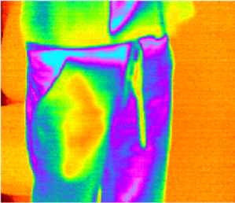

Fig. 1. Thermal image of a concealed gun

* 1. **CONVERT IR IMAGE TO HSV**

The IR/Thermal image captured will be converted to the HSV color model. HSV stands for Hue, Saturation and Vibrance(brightness). Since the IR/Thermal image is also partly dependent on the amount of light that is hitting the object, some information may be lost in those images. In order to preserve as much information as possible, this step is carried out as descriptions in terms of brightness and hue can potentially be more relevant. This concept of conversion is taken from [4].

* 1. **COMPLEMENT OF IR/THERMAL IMAGE**

Since the IR/Thermal image can sometimes have irregular levels of brightness and by extension information, which can make object discrimination difficult, we take the complement of IR/Thermal image to remove the darkness and improve feature extraction. This operation is done by mathematically subtracting the component of IR matrix from 255 because the intensity of IR image range between 0 to 255 or by reverse the value of each component.

# METHODOLOGY OF IMAGE PROCESSING

# Fig. 2. depicts the detailed system design from input to output in two steps of getting the results of weapon detection. The Image Processing stage is the most complicated stage of this method as a lot of manipulation operations need to take place in order to get an image that is robust enough so that the concealed weapon can be detected with maximum accuracy.

# There has been a lot of research lately in the domain of image processing. [4] explains how DWT (Discrete Wavelet Transform) can be a potentially strong method in the case of RGB and IR images, while [2] explores how LatLRR (Latent Low Rank Representation) can be used for fusing the IR/Thermal Image with RGB or HSV images. However, this technique failed to provide good fused image in terms of obtaining reasonable values of the statistical parameters such as PSNR, Normalized correlation (NC) and MSE. Fig. 3. compares the results of DWT Image fusion with LatLRR Image fusion technique. Since the results from DWT were containing a more robust definition of the hidden weapon, it was decided to use DWT for the objective of concealed weapon detection.

# 

# Fig. 2. Image Processing procedure

# 

# Fig. 3. LatLRR v/s DWT

* 1. **IMAGE PREPARATION AND PREPROCESSING**

Any image taken by sensor can have surplus and other extra parts such as the dark or semi dark background. The preprocessing is necessary to remove the undesirable parts in whole image and give the images in proper situation. Also, in order to perform image fusion, we need to make sure that both the input images are of the same size i.e. dimensions. Since these two input images are taken from two different image sensing devices so they are of different size. Hence, we will resize the input images.

* 1. **COMBINING THE RGB AND IR/THERMAL IMAGE BEFORE IMAGE FUSION**

Before the image fusion step, we combine the RGB image with the complement of IR/Thermal image by performing the addition operation on the images. This is done in order to ensure that the input images can be as robust as possible and can contain maximum amount of information.

* 1. **IMAGE FUSION**

Since the requirement that the input images (HSV, IR/Thermal + RGB) have same dimensional qualities is satisfied, the fusion procedure can start. The advantages of image fusion over visual comparison of multi-modality are: (a) the fusion technique is useful to correct for variability in orientation, position and dimension; (b) it allows precise anatomic and physiological correlation; (c) it permits regional quantization. After considering the various fusion processes ([4] and [2]), it is finalized that DWT is the most robust process to accomplish this stage. Discrete wavelet transform (DWT) is a spatial frequency decomposition that provides a flexible multi resolution analysis of an image.

Many image processing operations like denoising, contrast enhancement, edge detection, segmentation, texture analysis and compression can be easily and successfully performed in the wavelet domain. Wavelet techniques thus provide a powerful set of tools for image enhancement and analysis together with a common framework for various fusion tasks. DWT involves converting the image from locative domain to frequency domain. The frequency domain in DWT divides the image in four part such as (LL, LH, HL, HH). The LL part have the information of saliency parts i.e., the details in the image and the (LH, HL, HH) have information of global parts i.e., contour of the objects in the image. The pixels of two bands can be combined by using 9 different combinations of Mean, Max and Min methods. After testing all the 9 methods of possible combinations, it was found out that the method “Mean-Min” works the best for smooth thresholding of the body and the weapon that body is carrying. The reason for selecting the “Mean-Min” operation was out of all the 9 possible operations, this was the one which was able to achieve respectable parameter performance in case of PSNR. Here, first term is Mean which means averaging the pixels value of approximate bands i.e. HH1 and HH2, while Min refers to the detailed coefficients, for which we are choosing the minimum detailed coefficients of the other 3 bands. (HH1, HH2), (HL1, HL2), (LH1, LH2).

Multi-scale decomposition of the image based on DWT extract low frequency information, as well as, horizontal, vertical and diagonal directions of the high frequency details consist of 4 bands. The first band is called as approximated coefficient band and other three are detailed featured coefficients consisting the 3 alignments of the edges of the image: horizontal, vertical, and diagonal. The extracted DWT coefficients of input images are utilized for doing the fusion process. Both of our images consist of 3 channels therefore we will fuse these channels individually and then combining these channels again to form a pseudo-colored image. Then we are applying IDWT to get reconstructed fused image. The results obtained in [10] clearly show that the important area (area of hidden weapon) has a high degree of changing with respect to the other areas in an image. The process is clearly visibly explained in Fig. 4.

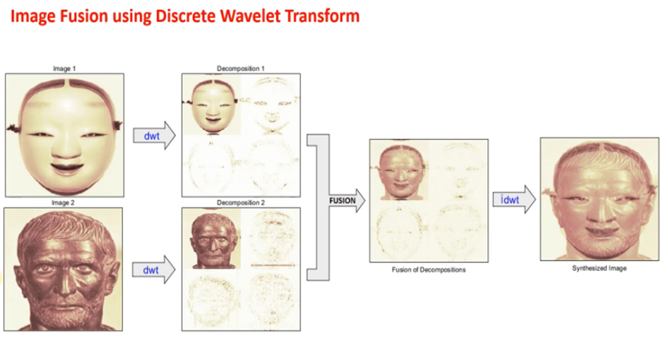

Fig. 4. Working of DWT Image Fusion

* 1. **SEGMENTATION USING OTSU’S THRESHOLDING ALGORITHM**

The main goal of Otsu algorithm is to find out the optimal gray level value to separate from other surrounding areas. This method involves iterating through all the possible threshold values and calculating a measure of spread for the pixel levels each side of the threshold, i.e. the pixels that either fall in foreground or the background. The aim is to find the threshold value where sum of foreground and background spreads is at its minimum. It calculates the foreground and background variances (the measure of spread) for a single threshold.

The next step is to calculate the ‘Within-Class-Variance’. This is simply the sum of the two variances multiplies by their associated weights. This final value is the ‘sum of weighted variances’ for the threshold that we have taken. These calculations are performed for all the possible threshold values.

Then it selects the threshold with lowest sum of weighted variances. After selecting the optimum threshold, all the pixels with a level less than the selected threshold are background, while the rest of the pixels constitute the foreground.

This can be done by converting the pixels below threshold to 0 and to 1 for pixels above threshold value.

Below is equation of this process:

The g (x, y) threshold version of f (x, y) at global threshold T, the equation will be

*g (x, y) = 1 if f (x, y) ≥ T otherwise=0* (1)

The threshold operation is

*T = M [x, y (x, y), f (x, y)]*

*where T=standard for the threshold, f (x, y) is the gray level of point (x, y) and p (x, y)* (2)

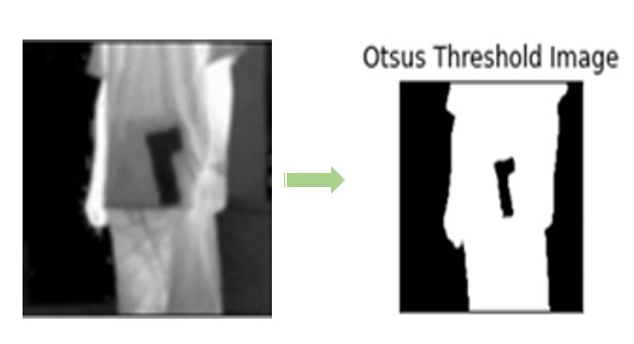

Fig. 5. Demonstration of Otsu’s Thresholding Algorithm

# WEAPON DETECTION

Once the binary image is received after the image fusion and processing step, the image is passed on for the neural network to identify if a weapon is present or not. In order to achieve this, various computer vision algorithms can be utilized. [6] talks about using the YOLOv6 algorithm specifically for object detection, which in this case is a weapon. According to [6], using this approach can isolate only the important segments of the image reducing the possibility of obtaining false positives. These segments will then be used as input for the firearm detection model which is a Convolutional Neural Network. For the detection of the firearm VGG Net can be used since it uses small convolutional filters while implementing large number of layers. According to [8], Fuzzy KNN (K-Nearest Neighbors) can be another potential technique which can be utilized for weapon detection in x-ray images. Since the scope of this research is to establish a method which can replace the conventional method, it was decided to explore other potential alternatives.

### CONVOLUTIONAL NEURAL NETWORKS

A Convolutional Neural Network (CNN) is a Deep Learning algorithm which can take in an input image, assign importance (learnable weights and biases) to various aspects/objects in the image and be able to differentiate one from the other. Convolutional neural networks are composed of multiple layers of artificial neurons. Artificial neurons, a rough imitation of their biological counterparts, are the mathematical functions that calculate the weighted sum of multiple inputs and outputs an activation value. The behavior of each neuron is defined by its weights. When fed with the pixel values, the artificial neurons of a CNN pick out various visual features. CNNs are one of the oldest and one of the most popular neural networks used for Computer Vision. In the case of weapon detection, CNN can be utilized but the time complexity of CNN is a very significant factor why CNN will not be used for this objective.

* 1. **LOGISTIC REGRESSION**

Although using this concept for object detection might mean deviation from the tried and tested methods, it can prove to be a very powerful technique [14]. Basically, logistic regression is a statistical method for predicting binary classes. The outcome or target variable is dichotomous in nature. Dichotomous means there are only two possible classes. This means that this algorithm will classify images into weapon vs non weapons instead of just identifying the hidden object. It computes the probability of an event occurrence, which in this case is the presence of weapon. This algorithm can further be tweaked to identify the weapon by classifying the weapon as gun v/s knife and firearms v/s other weapons.

1. **TEST RESULTS**
   1. **IMAGE PROCESSING**

The Image processing stage mentioned in section 4 was carried out using Jupyter Notebook (Python language), on a couple of sample images and the test results are presented in Fig. 4 and Fig. 5.

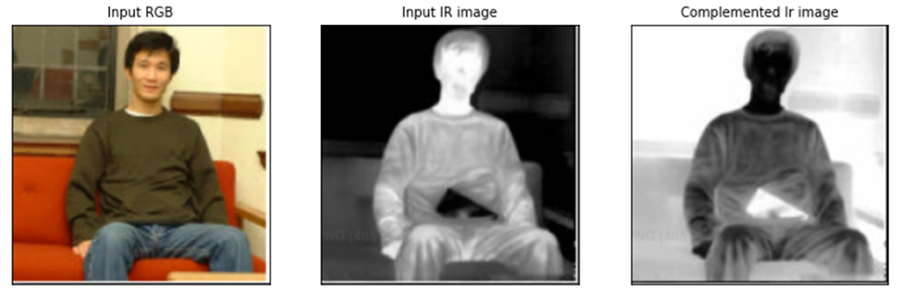

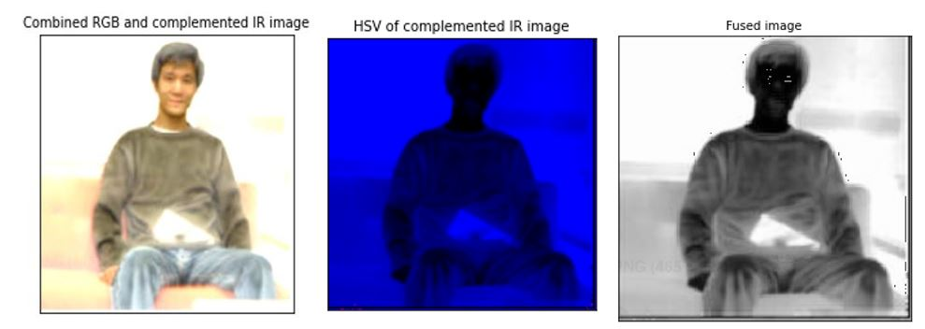

Fig. 6. Test results of DWT image fusion – 1

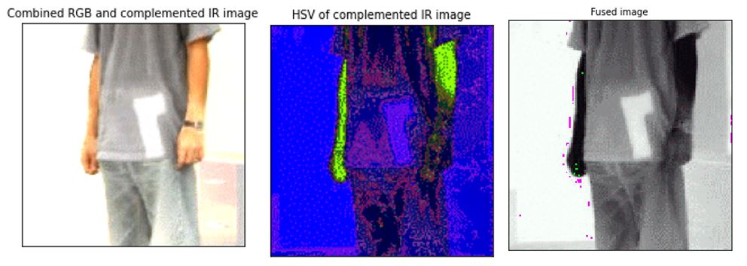

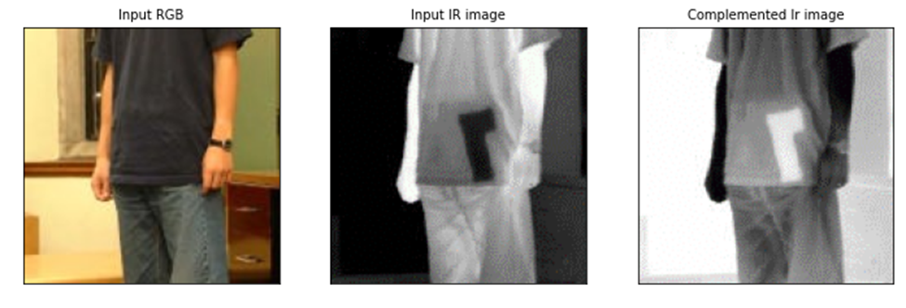

Fig. 7. Test Results of DWT Image Fusion – 2

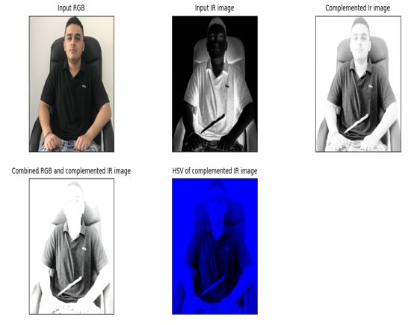

Fig. 8. Test results of DWT image fusion – 3

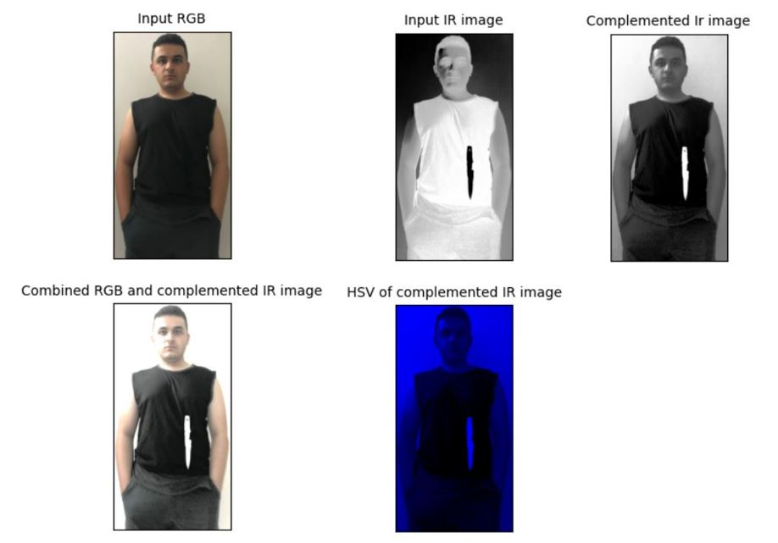

Fig. 9. Test results of DWT image fusion – 4

* 1. **SEGMENTATION**

The segmentation procedure mentioned in section 4.4 has been carried out using Python in Jupyter Notebook so that the fused image can be processed completely in order for the weapon to be detected without any hassles or problems. The results are shown in Fig. 8 and Fig. 9.

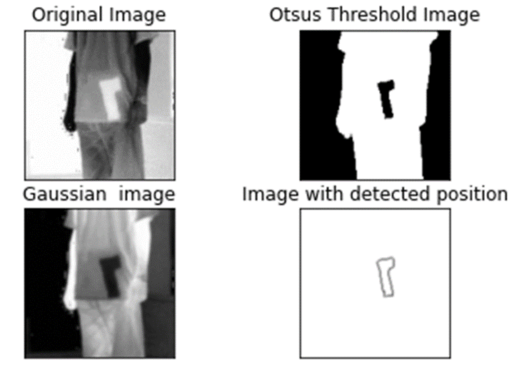

Fig. 10. Segmentation for images in Fig. 7

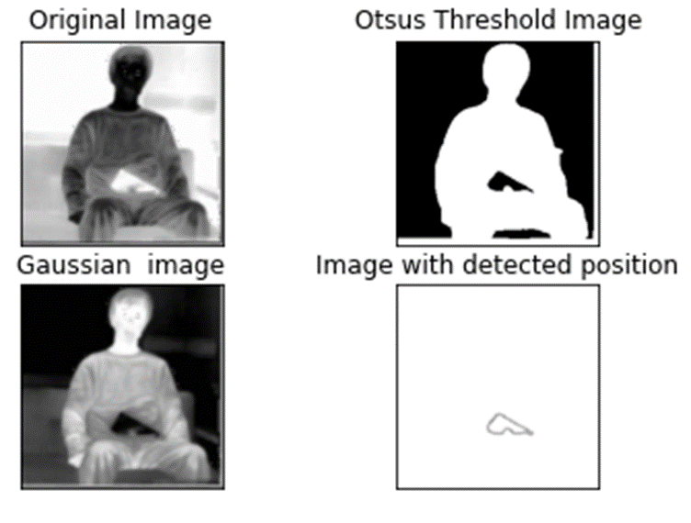

Fig. 11. Segmentation for images in Fig. 6

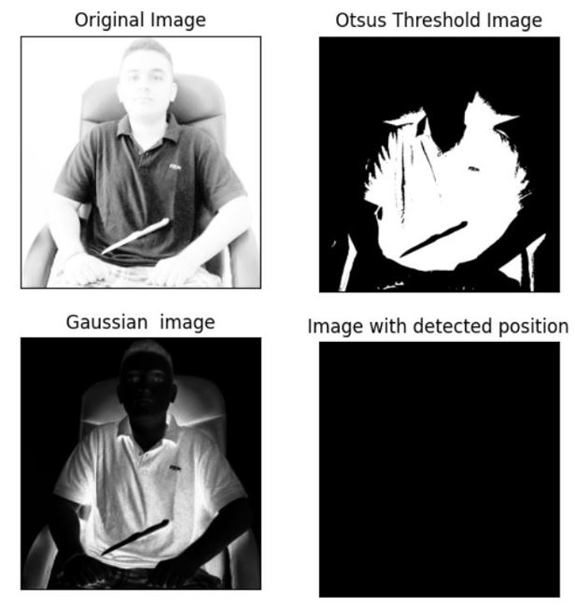

Fig. 12. Segmentation for images in Fig. 8

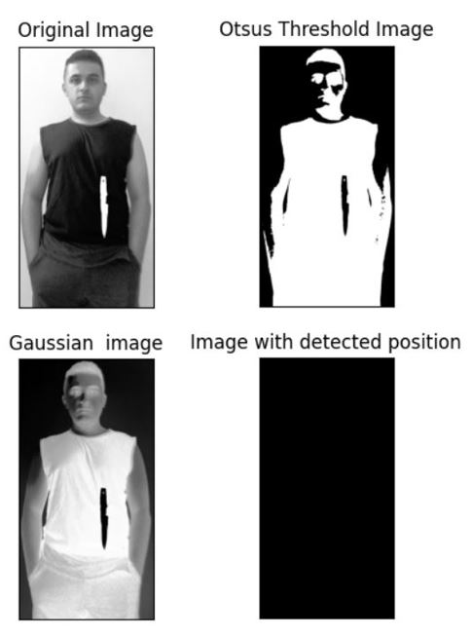

Fig. 13. Segmentation for images in Fig. 9

* 1. **WEAPON DETECTION/CLASSIFICATION**

In order to detect/classify the weapon, we have used logistic regression as specified in section 5.2. A neural network model was created and was trained using a custom dataset created by us containing 1759 images of weapons. One of the major advantages of using logistic regression is that it is does not require a very large sample size of dataset to predict with high accuracy and the presence of various libraries that offer consistent support in Python language makes it all the more convenient.

In order to facilitate the use of this model for our objective, we trained the logistic regression model with a custom dataset consisting of 1759 images, which was created keeping in mind the kind of images which will be sent as input to the weapon classification model i.e. focused on the shape of the weapon. Fig. 14. shows the type of images which were used in the custom dataset.

Fig. 15. shows the performance parameters of the model which were displayed by Jupyter Notebook, where the entire simulation process was carried out.

In order to verify the performance parameters, 32 random images were passed to the model for testing. Table. 1. shows the outcome of testing.

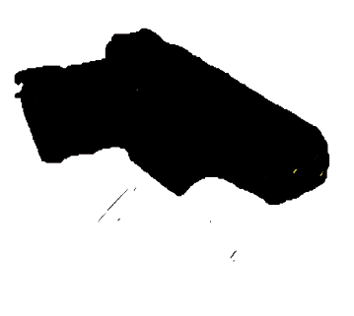 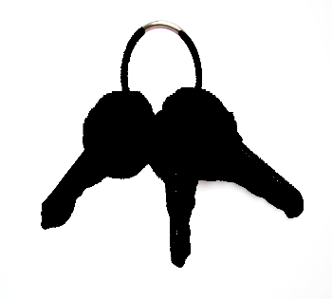

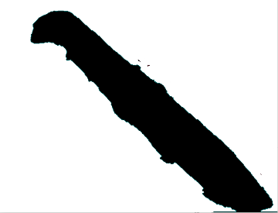 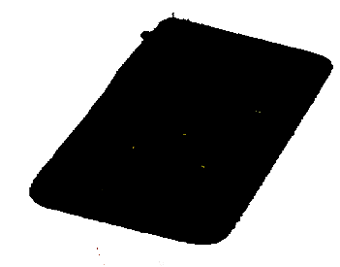

Fig. 14. Images used in training dataset (weapon and non-weapon)

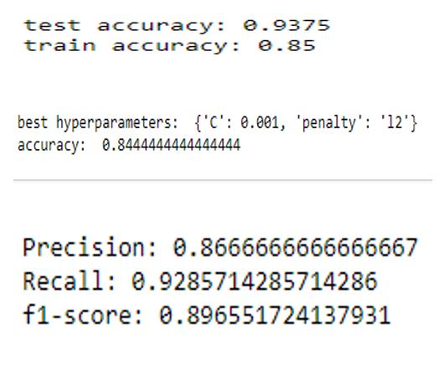

Fig. 15. Model Parameters

Table. 1. Testing result statistics

|  |  |  |
| --- | --- | --- |
| **S. No.** | **Class of Object** | **Outcome** |
| 1 | Weapon | TP |
| 2 | Non weapon | TN |
| 3 | Non weapon | TN |
| 4 | Weapon | TP |
| 5 | Weapon | TP |
| 6 | Non weapon | TN |
| 7 | Non weapon | FP |
| 8 | Non weapon | TN |
| 9 | Weapon | TP |
| 10 | Non weapon | TN |
| 11 | Non weapon | TN |
| 12 | Non weapon | TN |
| 13 | Non weapon | TN |
| 14 | Weapon | TP |
| 15 | Weapon | FN |
| 16 | Weapon | TP |
| 17 | Non weapon | TN |
| 18 | Non weapon | FP |
| 19 | Non weapon | TN |
| 20 | Weapon | TP |
| 21 | Weapon | TP |
| 22 | Weapon | TP |
| 23 | Non weapon | TN |
| 24 | Non weapon | FP |
| 25 | Weapon | FN |
| 26 | Non weapon | TN |
| 27 | Weapon | TP |
| 28 | Non weapon | TN |
| 29 | Weapon | TP |
| 30 | Non weapon | TN |
| 31 | Non weapon | TN |
| 32 | Weapon | TP |

Where: TP = True Positive FP = False Positive

FN = False Negative TN = True Negative

Using the above statistics, we calculate the various performance parameters as below:

Accuracy = TP+TN = 84.375%

TP+FP+FN+TN

Precision = TP = 86.66%

TP + FP

Recall = TP = 0.9285

TP + FN

F1 Score = 2*(Recall*Precision) = 0.8965

(Recall + Precision)

Some of the test results have been depicted in the figures below:

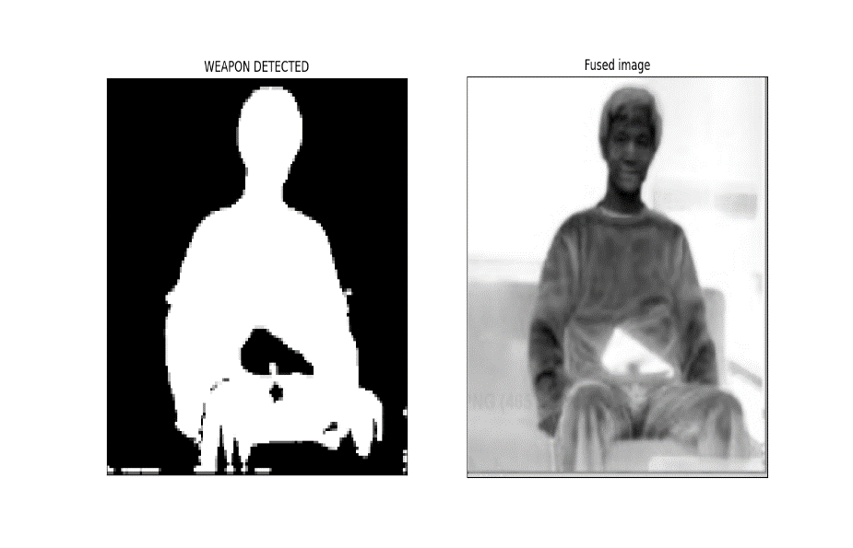

Fig. 16. Final Result for Fig. 6

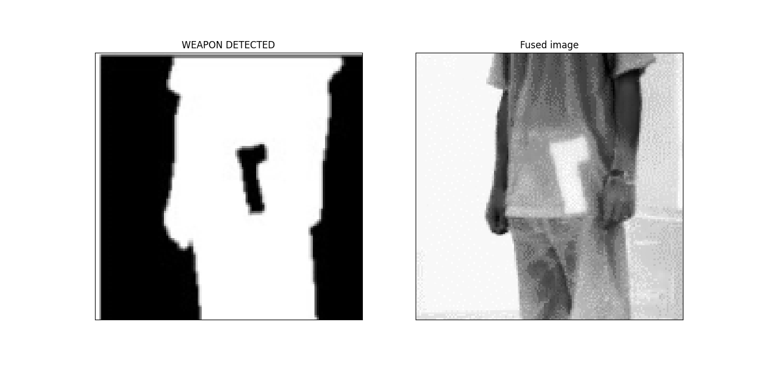

Fig. 17. Final Result for Fig. 7

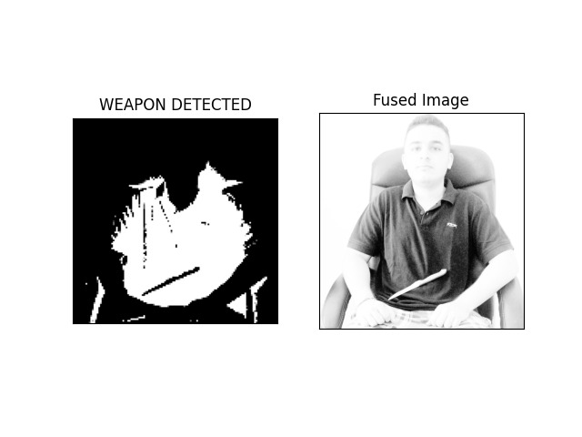

Fig. 18. Final Result for Fig. 8

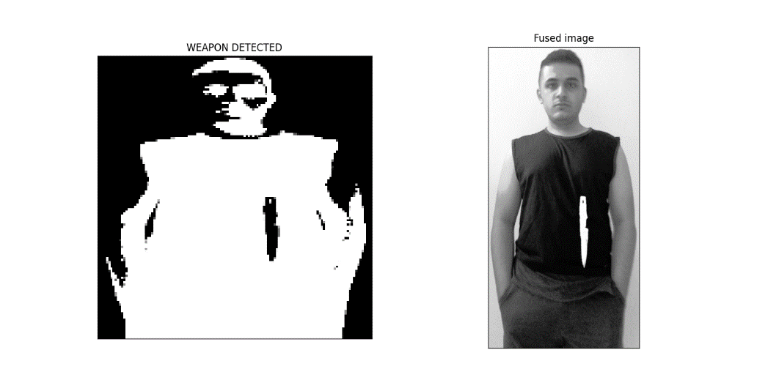

Fig. 19. Final Result for Fig. 9

1. **CONCLUSION**

The aim of this research topic was to identify a way to replace the traditional method of concealed weapon detection and to achieve a viable method of concealed weapon detection process automation, which has been achieved by visualizing a different approach to object detection. With the help of Image processing operations, we were able to isolate the concealed weapon for effective classification of the hidden object as a weapon or a non-weapon, while also being able to retain the facial characteristics of the person carrying the weapon so as to facilitate immediate neutralization of the potential threat. The use of machine learning is done to minimise the human effort to identify the concealed object and detect if the object is a weapon or not. This research contributes in the field of surveillance and by extension effective governance.

**REFERENCES**

[1] D. M. Sheen, D. L. McMakin and T. E. Hall, "Three-dimensional millimeter-wave imaging for concealed weapon detection," in IEEE Transactions on Microwave Theory and Techniques, vol. 49, no. 9, pp. 1581-1592, Sept. 2001, doi: 10.1109/22.942570.

[2] S. Yu and X. Chen, "Infrared and Visible Image Fusion Based on a Latent Low-Rank Representation Nested With Multiscale Geometric Transform," in IEEE Access, vol. 8, pp. 110214-110226, 2020, doi: 10.1109/ACCESS.2020.3001974.

[3] S. Yuenyong, N. Hnoohom and K. Wongpatikaseree, "Automatic detection of knives in infrared images," 2018 International ECTI Northern Section Conference on Electrical, Electronics, Computer and Telecommunications Engineering (ECTI-NCON), 2018, pp. 65-68, doi: 10.1109/ECTI-NCON.2018.8378283

[4] Prof. Samir K. Bandyopadhyay, Biswajita Datta, Sudipta Roy, “Identifications of concealed weapon in a Human Body” in IJSER, vol. 3, no. 11, pp. 240-246, Nov. 2012

[5] Bhavna Khajone, Prof. V. K. Shandilya, “Concealed Weapon Detection Using Image Processing” in IJSER, vol. 3, no. 6, pp. 893-896, June. 2012

[6] Piyadasa, Tharinda. (2020). Concealed Weapon Detection Using Convolutional Neural Networks.

[7] Mahadevi Parande, Shridevi Soma, "Concealed Weapon Detection in a Human Body by Infrared Imaging", International Journal of Science and Research (IJSR), https://www.ijsr.net/search_index_results_paperid.php?id=SUB157915, Volume 4 Issue 9, September 2015, 182 – 188

[8] Roomi, Mansoor. (2012). Detection of Concealed Weapons in X-Ray Images Using Fuzzy K-NN. International Journal of Computer Science, Engineering and Information Technology. 2. 187-196. 10.5121/ijcseit.2012.2216.

[9] Zhang, Zhong & Blum, Rick. (2003). Region-Based Image Fusion Scheme For Concealed Weapon Detection.

[10] Chen, Hua-mei & Lee, Seungsin & Rao, Raghuveer & Slamani, Adel & Varshney, P.K.. (2005). Imaging for concealed weapon detection - A tutorial overview of development in imaging sensors and processing. Signal Processing Magazine, IEEE. 22. 52 - 61. 10.1109/MSP.2005.1406480.

[11] Acharya, T. and Ray, A.K. (2005). Discrete Wavelet Transform. In Image Processing (eds T. Acharya and A.K. Ray). https://doi.org/10.1002/0471745790.ch5

[12] Deng A., Wu J., Yang S. (2011) An Image Fusion Algorithm Based on Discrete Wavelet Transform and Canny Operator. In: Lin S., Huang X. (eds) Advanced Research on Computer Education, Simulation and Modeling. CESM 2011. Communications in Computer and Information Science, vol 175. Springer, Berlin, Heidelberg. https://doi.org/10.1007/978-3-642-21783-8_6

[13] Verma, Gyanendra & Dhillon, Anamika. (2017). A Handheld Gun Detection using Faster R-CNN Deep Learning. 84-88. 10.1145/3154979.3154988.

[14] Peng, Joanne & Lee, Kuk & Ingersoll, Gary. (2002). An Introduction to Logistic Regression Analysis and Reporting. Journal of Educational Research - J EDUC RES. 96. 3-14. 10.1080/00220670209598786.

[15] Xue, Zhiyun & Blum, Rick. (2003). Concealed weapon detection using color image fusion. Proceedings of the 6th International Conference on Information Fusion, FUSION 2003. 1. 622- 627. 10.1109/ICIF.2003.177504.